
SHED NO 27, SHUBHAM INDUSTRIAL ESTATE, NR. TORENT POWER SUB STATION, KATHWADA GIDC, AHMEDABAD – 382430
GST NO: - 24ARDPD2565K1ZX

info@torqpackagingsolution.com
www.torqpackagingsolution.com

Date: - 18/03/24.
To.
MR. : CHETHANA DAVANAGERE.

Sub: - Automatic 2 head semi liquid filling machine.

Dear Sir,
Many thanks for your valuable inquiry of above subject. TORQ PACKAGING Solutions Is engage in making preliminary Bottle Packaging machines like bottle filling , capping , labeling, Automation, etc… in Ahmedabad, We are having dedicated team for manufacturing, customized machine development, Sales, servicing and back office.

Thanks & Regards
Ronak Dave
+91 80000 32128

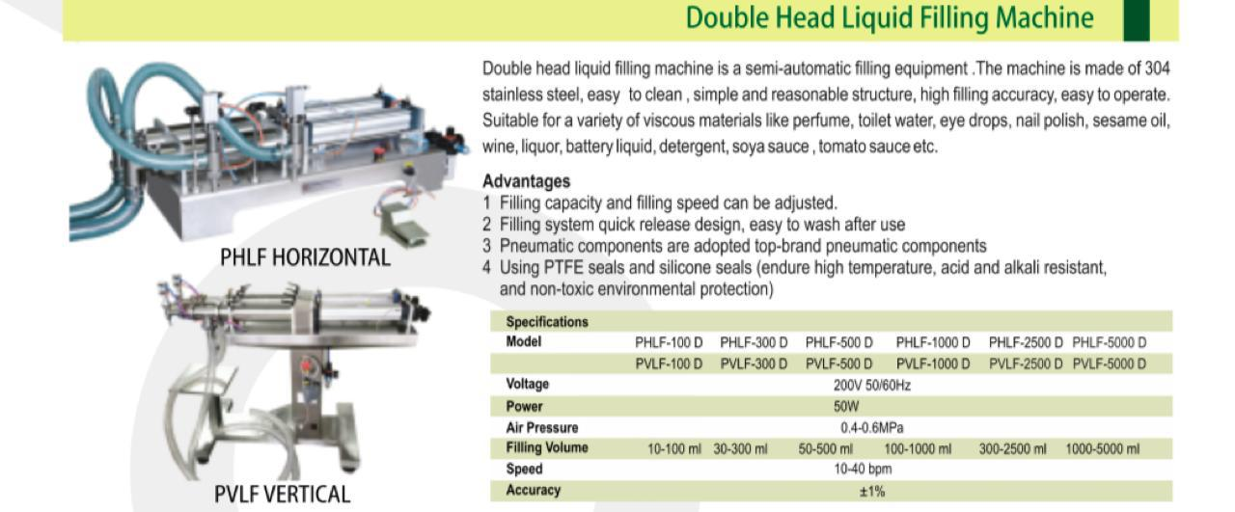

PriceBreakup
S.N. | PARTICULERS | CAPACITY | QTY | AMOUNTRS.
1 | Double head semi liquid Filling Machine. | 10 to 100 ml | 1 | 51,000/-
2 | Double head semi liquid Filling Machine. | 100 to 1000 ml | 1 | 55,000/-
 | BANKDETAIL:  Accountname :- TORQ PACKAGING SOLUTION  Accountnumber:- 8000032128  Bankname:- KOTAKMAHINDRABANKLTD  Branch :- KATHWADA  IFSC:-KKBK0002606  COMPANYGSTIN:24ARDPD2565K1ZX | TOTAL |  | 1,06,000/- | 7,30,000/-
 |  | CGST@9%
 |  | SGST@9%
 |  | IGST@18% |  | 19,080/-
TOTALAMOUNT |  |  |  | 1,25,080/-
TERMS&CONDITIONS |  | For,TORQPackaging Solution
- 50%AdvanceonSigningupofContract
- 50% On Completion ofMachineryManufacturingBeforeDispatch/DuringInspectionofmachinery
- OrderOncePlacedCannotbeCancelled
- NoRefundwillbeentertained

